Project Design Phase-II

Data Flow Diagram & User Stories

|  |  |
| --- | --- |
| Date | 03 October 2023 |
| Team ID | Team-591577 |
| Project Name | Potato Disease Classification |
| Maximum Marks | 4 Marks |

# Data Flow Diagrams:

A Data Flow Diagram (DFD) is a traditional visual representation of the information flows within a system. A neat and clear DFD can depict the right amount of the system requirement graphically. It shows how data enters and leaves the system, what changes the information, and where data is stored.

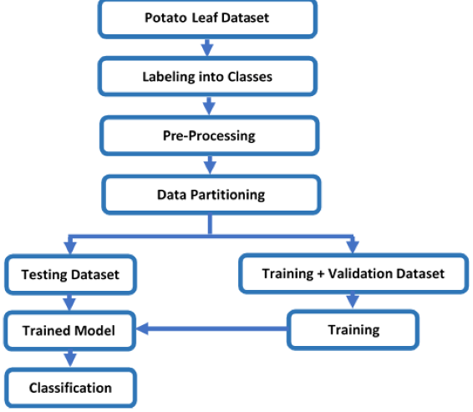

**User Stories**

Use the below template to list all the user stories for the product.

|  |  |  |  |  |  |  |
| --- | --- | --- | --- | --- | --- | --- |
| **User Type** | **Functional**  **Requirement (Epic)** | **User Story Number** | **User Story / Task** | **Acceptance criteria** | **Priority** | **Release** |
| Customer (Mobile user) | Registration | USN-1 | As a user, I can register for the application by entering my email, password, and confirming my password. | I can access my account / dashboard | High | Sprint-1 |
|  |  | USN-2 | As a user, I will receive confirmation email once I have registered for the application | I can receive confirmation email & click confirm | High | Sprint-1 |
|  |  | USN-3 | As a user, I can register for the application through Facebook | I can register & access the dashboard with Facebook Login | Low | Sprint-2 |
|  |  | USN-4 | As a user, I can register for the application through Gmail |  | Medium | Sprint-1 |
|  | Login | USN-5 | As a user, I can log into the application by entering email & password |  | High | Sprint-1 |
|  | Dashboard |  |  |  |  |  |
| Customer (Web user) | Login | Any user | As a customer the person has to login before using the web page | He can receive email confirmation or login via google | Medium | Sprint – 1 |
| Customer Care Executive | Help desk | Agent | As our website agent he will help customer to go through our website and attend Queries | By call or a chat application | Medium | Sprint -2 |
| Administrator | Maintenance | Admin | As an Administrator he will check and update the website time to time and notify to the customers | Admin Passwords | High | Sprint - 0 |
| Guest | No login | Guest | As a guest he can see our website and read all the criteria and get the idea of our website | Sign in | Low | Sprint – 1 |
| Owner | Login | Owner | As a Owner he owns the website and have all the copy right policies | Administrations | High | Sprint - 0 |
|  | Administration | Admin | Being owner he can change the work of administrator and change anything | Administration | High | Sprint – 0 |